IXX1410 „Tarkvara projekt“ – 3EAP

Projekti teema valik:
Arduino Uno projekt (Tarkvara + Riistvara):
- Ilmajaam
- Äratuskell
- Töötundide loendur RF ID

Projekti hinne:
Koondtulemus = H1+ H2 + H3

H1 = 20% = 5+5+10
esitluse tase (projekti esitlus, vahekaitsmine, lõppkaitsmine)
H2 = 20% = 2*8 + 4(bonus)
osavõtt õppetööst (Arduino ja oma projekti täitmine)

H3 = 60% lahenduse tase (oma projekti keerukus, funktionaalsus, projekti aruanne)

Projekti kaitsmine:
Projektide kaitsmine toimub avalikult õppesemestri viimastel nädalatel (01.05, 08.05, 15.05) teiste antud eriala üliõpilaste osalusel

Praktikumide läbiviimine:

ICT-507C?, Paaritu nädal 14:00 – 17:00?
Õppejõud: Marina Brik, Sergei Kostin
Tarkvara – Arduino IDE (https://www.arduino.cc/en/Main/Software)
Riistvara – Arduino UNO
(https://store.arduino.cc/arduino-uno-rev3)

Kuidas kasutada Arduino mikrokontrollerit ja komponente - https://www.arduino.cc/en/Guide/HomePage

Arduino projektid - https://store.arduino.cc/genuino-starter-kit

Praktikumid:

14.02
- Introduction to “The Arduino Starter Kit” (30 min)
- Project 1: Get to know your tools: switches, LED, resistor (30 min)
  - discover: basic electrical theory, how a breadboard works, components in serial and parallel
- Project 2: Spaceship interface: (45 min)
  - discover: digital input and output, your first program, variables
- Project 3: Love-o-meter: LED, resistor, temperature sensor (45 min)
  - discover: analog input, using serial monitor
- Project 6: Light Theremin: Piezo, photoresistor, resistor (45 min)
  - discover: making sound with the tone() function
- Project 7: Keyboard instrument: Piezo, switch, resistor (45 min)
  - discover: resistor ladders, arrays

Aine registreerimine ja materjalide kättesaadavus:
https://edu.pld.ttu.ee

Modules & Sensors:
via I2C (A4-SDA (serial data), A5-SCK or SCL(serial clock), VDD, GND)
- OLED 0.96 inch display 128x64: Adafruit_SSD1306 (~ 2 eur)
- add Adafruit_SSD1306-master and Adafruit-GFX-Library-master libraries
- In Adafruit_SSD1306.h and your sketch check the display address, it must be 0x3C
- In Adafruit_SSD1306.h uncomment line
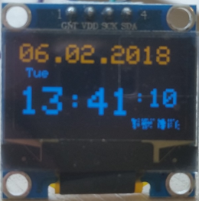
#define SSD1306_128_64 and comment line #define SSD1306_128_32

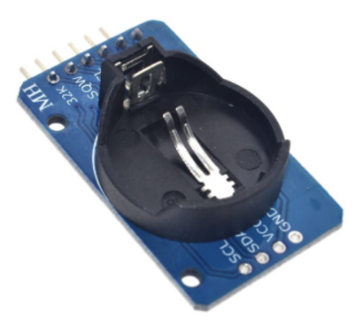
- DS3231 precise clock module: (~1 eur)
- Add library RTClib-master

- BMP280 pressure & amplitude & temperature sensor: (~0.9 eur)
- Add library Adafruit_BMP280_Library-master
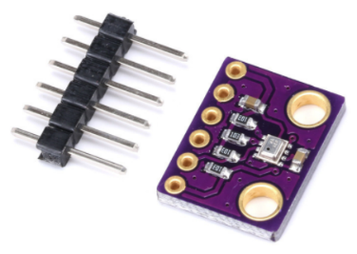
- In Adafruit_BMP280.h: #define BMP280_ADDRESS (0x76) not 0x77

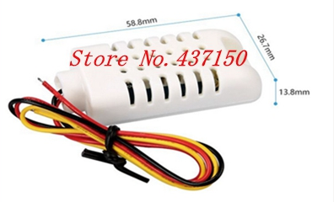
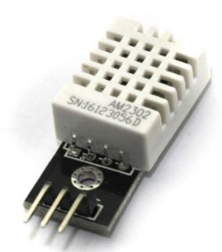
- DHT22 temperature & humidity sensor: (~1.4 eur)
- Add library arduino-DHT-master

- RC522 RFID module (~1.5 eur)
- Add library MFRC522-1.2.1
- http://educ8s.tv/arduino-rfid-tutorial/
- https://www.youtube.com/watch?v=So83sH6-jwM
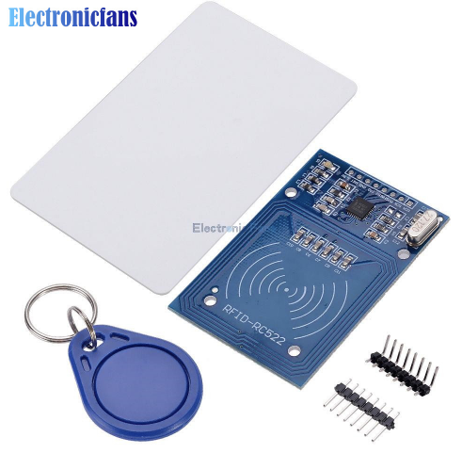

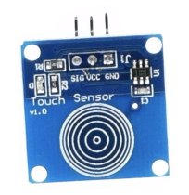
- TTP223B puuteandur touch sensor (~0.4 eur)
- ESP8266 WIFI module (~2.5 eur) on Node MCU 1.0 board
- Install CP210x USB to UART Bridge VCP Driver
https://www.silabs.com/products/development-tools/software/usb-to-uart-bridge-vcp-drivers
- Install the ESP8266 Board
https://randomnerdtutorials.com/how-to-install-esp8266-board-arduino-ide/
- Select board Node MCU 1.0 (ESP-12E Module)
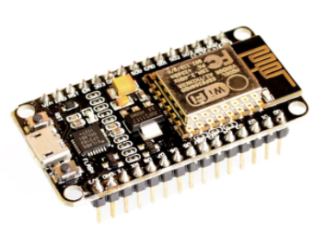
https://bennthomsen.wordpress.com/iot/iot-things/esp8266-wifi-soc/esp8266-getting-started-with-arduino-ide/
- Attach Adafruit SSD1306 OLED display to following pins:
(display)SDA -> D2 and (display)SCL->D1

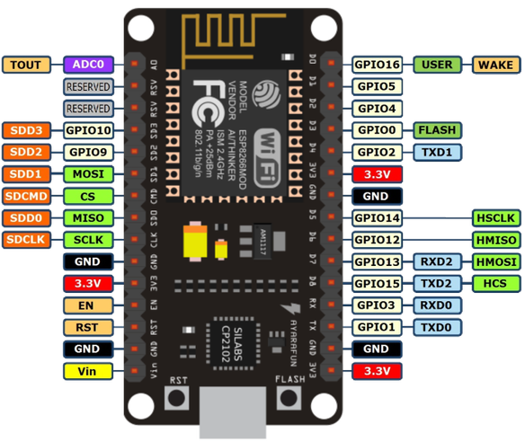
NB! DO NOT USE PINS D3, D4 and D8 since they are used to upload your program to the device

